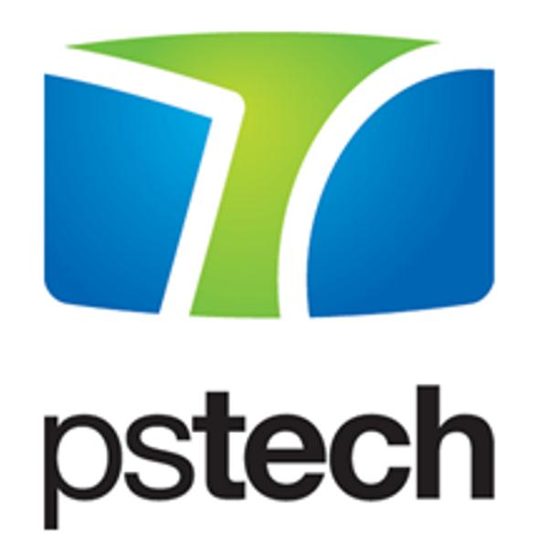
With over 15 years of experience in the area of software development we have established long-term relationships with our clients. They trust our decisions and value our propositions. During the last two years we have grown from 140 to around 300 great people and we keep going. Join one of the biggest software development companies in the region and become a member of our daily-growing team.

Our clients are world leaders in their business areas. Our projects include object oriented software development, database design and mobile platforms. Also, our functional and performance testing expertise is highly valued by our clients. Our core values: partnership, innovation and respect, represent our business approach so as our employee focus.

Due to strong demand for our services, we are looking for:

C++ Software Developer – Unified Communications

You will be a part of a team that works on a project for one of our clients on integration of real-time communication services (such as instant messaging, presence information, telephony, video conferencing, desktop and data sharing) with non-real-time communication services (such as voice mail) in a consistent unified user-interface.

As a C++ Software Developer you will need to be up to date with the latest innovations in C++ language, have broad interest and knowledge in various disciplines and possess verbal/written communication skills. This is an excellent opportunity for an engineer to gain an invaluable experience. We are looking for intelligent and sharp candidates that are hungry for knowledge and growth. Don’t miss the opportunity to work in a casual, yet professional environment with smart and talented people.

Qualified candidates will participate on a project within a team of engineers involved in maintenance and development of software products on various platforms (Windows, OS X, iOS, Android), with responsibilities that may include any of the following:
- Gathering and analyzing requirements
- Assisting in the design of a technology solution
- Assisting in the implementation of a solution
- Working with appointed project leads to estimate tasks
- Create, execute and document tests to ensure that an application meets requirements and functional specifications
- Product maintenance
- Custom reporting
- Debug problems of moderate scope at the subsystem level
- Perform complex subsystem level unit and integration tests
- Identifying and resolving problems found during internal verification testing at customer sites
- Candidates must be able to assume complete responsibility and ownership for tasks assigned

We take good care of our people, this is what we offer:
- Participate in projects where your opinion will be valued
- Enjoy the pleasant working environment, have fun and play
- Take full ownership of your career and benefit from our development opportunities

But we set the bar high, here is what we expect:
- Demonstrated successful programming on a real-time, multi-threaded, software products
- Good understanding and experience with: C++, Boost
- Experience with client/server development and network programming
- Demonstrated skills in troubleshooting and debugging complex software
- Experience and comfort understanding, maintaining, and enhancing other people’s code
- Strong verbal and written communication skills, with the ability to work cross-functionally
- Open-minded for learning new technologies and processes
- Thinking outside of the box (finding creative and sometimes unusual solutions)
- Initiative in suggesting improvements in processes and the product

If you are interested in this position and you have the required qualifications, please send your CV via email to posao@pstech.rs. Please note that due to large number of applications we receive, we will only contact those candidates that are selected for an interview. Thank you.

